**What the paper contributes to knowledge?**

* We present a CFD-MPM model that simulates the entire process of submarine landslides.
* Our research highlights the critical role of permeability: (1) Slower dissipation of excess pore water pressure leads to an increase in the debris runout. (2) Permeability also governs the failure mechanism of submarine landslides in different sediment types. Lowering permeability triggers a transition from a sand flow slide to a clay spreading mechanism.

**What evidence the paper created to support the contribution claims?**

The model is validated based on centrifuge experiments of earthquake induced submarine landslides.

**What is particular novel about the insights generated in the research?**

Unlike other current model in literature, our model (1) incorporates effective stress analysis, providing a comprehensive understanding of triggering mechanisms and excess pore water pressure development and (2) offers unique capabilities for exploring earthquake-induced submarine landslides with exceptional detail and accuracy.

**Why the contributions matter? (What problems are addressed / What opportunities are created)**

For landslide risk assessment

**What the limitations of the research are?**

Constitutive model is not the best option for cyclic behavior of soil.

**What next steps are suggested?**

New constitutive model for cyclic loading.

.

**Mechanism of Earthquake-Induced Submarine Landslides and the Influence of Sediment Permeability: Centrifuge Validation and CFD-MPM Analysis**

Quoc-Anh Tran1, Erik Sørlie1, Gustav Grimstad1, Gudmund Eiksund1, Hidenori Takahashi2, Shinji Sassa2

1 Department of Civil and Environmental Engineering, Norwegian University of Science and Technology, Norway.

2 Port and Airport research Institute, Yokosuka, Japan.

ABSTRACT

Seismic induced submarine landslides pose a significant risk to offshore structures. To better understand this phenomenon, we have developed a CFD-MPM model that allows us to simulate the complete seismic induced submarine landslide mechanism. Recent centrifuge experiments have demonstrated that the permeability of marine sediment is a critical factor in determining the failure mechanism of submarine landslides. Specifically, reducing permeability can trigger a change from slope failure to debris flow. Our CFD-MPM model has been validated with these experiments and confirms this finding. Moreover, we conducted a sensitivity analysis of the seismic induced submarine landslide mechanism using our model. We found that lower permeability leads to slow dissipation of excess pore water pressure, resulting in longer run-out of submarine debris flow. Furthermore, reducing permeability triggers a change in failure mechanism from sand flow slide to clay spreading, which resembles real-life observations. This study provides insights into the influence of sediment permeability on the mechanism of submarine landslides, which is crucial for hazard assessment and mitigation strategies in offshore engineering and coastal management.

KEYWORKS: earthquakes, submarine landslides, coupled Material Point Method and Computational Fluid Dynamics, large deformation modeling.

# Introduction

Submarine landslides pose a significant threat to offshore and nearshore structures, with potential consequences including severe impact forces, seabed entrainment, and tsunamis. (Harbitz et al., 2014; Locat & Lee, 2002; Puzrin, 2016). Previous incidents have resulted in the collapse of offshore platforms, pipelines, and seabed cables, as well as devastating damage caused by tsunamis (Heezen & Ewing, 1952; Parsons et al., 2014). Earthquakes are among the most common triggers of submarine landslides, which can occur due to natural factors or human-induced activities originating from onshore landslides (Locat & Lee, 2002).

The process of an earthquake-induced submarine landslide typically involves two stages: the pre-failure stage and the post-failure stage. During the pre-failure stage, seismic activity triggers slope failure, leading to the subsequent rapid movement of sediments in the post-failure stage. To assess the risk associated with submarine landslides, engineers have traditionally divided the problem into two separate steps. The pre-failure stage is evaluated using finite element analysis to compute the safety factor of seabed slopes in high-risk areas prone to seismic activity. Subsequently, the post-failure stage is assessed using computational fluid dynamics (CFD) to predict the consequences of the submarine landslides. However, this approach has limitations, as it is challenging to simulate the complete process of a submarine landslide due to the transition of seabed slopes from solid-like behavior in the pre-failure stage to fluid-like behavior in the post-failure stage.

To overcome these limitations, this paper presents a coupled Computational Fluid Dynamics – Material Point Method (CFD-MPM) model specifically designed for the assessment of earthquake-induced submarine landslides. Unlike previous models that adopt total stress analysis (e.g., Material Point Method (Shi et al., 2020), Smooth Particle Hydro Dynamics (Capone et al., 2010), Particle Finite Element Method (Zhang et al., 2019), or Coupled Eulerian Lagrangian method (Dey et al., 2016)), the CFD-MPM model (Tran et al., 2022) incorporates effective stress analysis, providing a more comprehensive understanding of the triggering mechanisms involved in the development of excess pore water pressure in both the pre-failure and post-failure stages. Moreover, it enables a detailed investigation of the complex interactions between sediment, seawater, and structures at every stage of the submarine landslide, including the modeling of secondary effects such as tsunamis. The uniqueness of our model lies in its ability to explore the intricate mechanisms of earthquake-induced submarine landslides in full detail.

To validate the model, geotechnical centrifuge experiments were conducted to simulate earthquake-induced submarine landslides at the Port and Airport Research Institute in Japan. The experiments demonstrated the significant role of the permeability in the transition from slope failure to gravity debris flows. It was observed that slowing the dissipation of excess pore water pressure was crucial for generating gravity flows, as liquefaction induced solely by seismic loading proved insufficient to generate long runouts of submarine debris flows (Takahashi et al., 2020). The numerical model successfully captured the transition from slope failure to debris flow, reproducing the development of excess water pressure observed in the experiments. Building on this validation, we further utilized the model to investigate the influence of the permeability on the failure mechanism of submarine landslides. Our hypothesis is that the permeability serves as a key parameter in determining the failure mechanisms, particularly in distinguishing between sand and clay slopes.

By integrating our validated CFD-MPM model with centrifuge experiments, we make two key findings that deepen our understanding of earthquake-induced submarine landslides. Firstly, our research highlights the critical role of the permeability in influencing the runout behavior of submarine debris flows. Both experiment and numerical results show that when the excess pore water pressure dissipates slowly, the extent of runout increases significantly. Secondly, our study reveals that the permeability also governs the failure mechanism of submarine landslides in different sediment types. Specifically, in the case of submarine clay slides, reducing the permeability triggers a transition from a sand flow slide to a spreading mechanism. This finding provides valuable insights into the complex behavior of different marine sediments under seismic disturbances and emphasizes the need to consider the permeability as one of the fundamental parameters in comprehensive modeling approaches.

# CFD-MPM Model

The coupled Computational Fluid Dynamics-Material Point Method (CFD-MPM) approach combines the strengths of both methods to simulate earthquake-induced submarine landslides, considering solid and fluid interactions. The Material Point Method (MPM) is employed to handle large deformations in solids and porous media, particularly for modeling the seabed and debris flows. On the other hand, Computational Fluid Dynamics (CFD) is utilized to analyze fluid dynamics, encompassing water and air.

The CFD-MPM approach offers several advantages by integrating these two methods. In the MPM component, sophisticated solid and soil constitutive models can be defined, which are crucial for capturing the initiation mechanism of the flow. The interaction between solids represented by MPM materials is governed by contact laws such as Coulomb's friction.

In contrast, CFD is a widely adopted method for simulating complex viscous fluid flows involving turbulence and hydroplaning, such as when debris flows lose friction with the seabed. By using CFD, the numerical instability of water pressure can be avoided, which would require additional numerical treatments in MPM, such as the B-bar method (Bandara & Soga, 2015), null-space filter (Tran & Sołowski, 2019), or least square approximation (Tran, Berzins, et al., 2019; Tran, Wobbes, et al., 2019; Zheng et al., 2021).

Overall, the CFD-MPM model provides a comprehensive framework for capturing the intricate mechanisms involved in earthquake-induced submarine landslides, accounting for solid-fluid interactions. This approach allows for a detailed analysis of the phenomenon, considering the complex behavior of solids and fluids in a unified simulation environment.

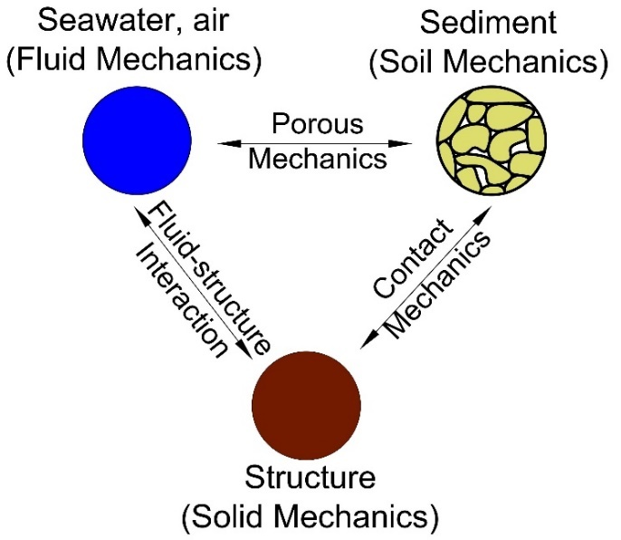

Figure Schematic of the soil-water-structure interaction

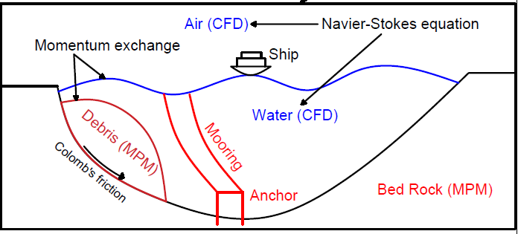

Figure Schematic of the soil-water-structure interaction

The coupled CFD-MPM model was implemented and validated within the Uintah computational framework (Tran et al., 2022) to accurately capture the triple interaction between soil, water, and structures. The CFD component is based on the implicit continuous-fluid Eulerian (ICE) method, where all state variables are located at the cell/body centers. These variables, represented as the material vector (M_r, u_r, e_r, T_r, p, ϕ_r, ν_r), encompass mass, velocity, internal energy, temperature, pressure, volume fraction, and specific volume. The MPM approach utilizes the generalized interpolation technique proposed by Bardenhagen and Kober (Bardenhagen & Kober, 2004). This technique has been validated through laboratory experiments (Tran et al., 2017a; Tran et al., 2017b) and large-scale landslide simulations (Tran & Sołowski, 2019a). To couple the MPM method with ICE, the state variables of the MPM material points, including mass, velocity, temperature, and effective stress (M_p, u_p, T_p, σ'), are mapped to the cell centers using the generalized interpolation technique. Subsequently, the governing equations are solved on the Eulerian background mesh.

By integrating these two methods, the coupled CFD-MPM model enables a comprehensive analysis of the soil-water-structure interaction, providing a robust framework for simulating the complex behavior of earthquake-induced submarine landslides. The model's validation and the utilization of established techniques ensure its accuracy and reliability in capturing the dynamic processes involved in these phenomena.

*Mass Balance Equation*

|  |  |  |
| --- | --- | --- |
|  |  | () |

*Momentum Balance Equation for fluid*

|  |  |  |
| --- | --- | --- |
|  |  | () |

*Momentum Balance Equation for solid*

|  |  |  |
| --- | --- | --- |
|  |  | () |

The last term is the momentum exchange between materials with dragging force f_d. Apart from mass and momentum balance equations, coupled CFD-MPM also solves the energy balance equations (not presented here in), all implicitly. However, we set the numerical simulations in the isothermal condition (no thermal expansion and conduction effect) for the sake of simplicity. This is also combined with the generalized Poisson’s equation to compute the fluid pressure for compressible fluid materials.

## *Momentum Exchange*

For the momentum exchange between fluid flows and porous media, we assume that the drag force f_d (Beetstra et al., 2007) is given by:

|  |  |  |
| --- | --- | --- |
|  |  | () |

where D_p is the average grain size of the grains, the solid volume fraction is ${}_{s}$,, the fluid viscosity is ${}_{f}$, Re is the Reynolds number and the relative velocities of soil grains and fluid is $(u_{s}-u_{f})$ which is calculated as:

|  |  |  |
| --- | --- | --- |
|  |  | () |

The function is given as:

|  |  |
| --- | --- |
|  | () |

where the low Reynold coefficient is:

|  |  |
| --- | --- |
|  | () |

Two grain sizes are selected for the numerical analysis (1) $D_{p}$ = 0.5 mm and (2)  = 1e-4 mm to mimic the hydraulic conductivity of sand and clay.

## *Fluid equation of state models*

The equation of state establishes relations between thermodynamics variables. For the air, the equation of state for the perfect gas is adopted while for the water, a simple linear equation of state can be written as:

|  |  |  |
| --- | --- | --- |
|  |  | () |

where reference pressure $P_{ref}$ = 1 atm = 101325 Pa, reference temperature $T_{ref}$ = 10 °C, reference density ${}_{ref}$ = 9.998 kN/m3, the bulk modulus of water $K_{f}$ = 2 GPa, and the water thermal expansion ${}_{f}$ = 0.18 °C-1. This equation matches well with the state of the water.

# Validation of centrifuge experiment results

## Brief description of the centrifuge experiment

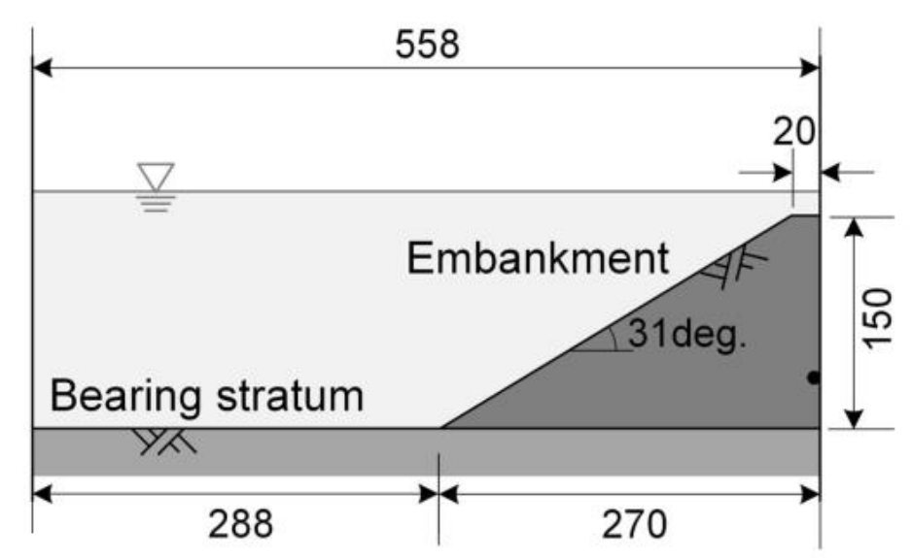

Figure Setup of the geotechnical centrifuge experiment of the earthquake induced submarine landslides

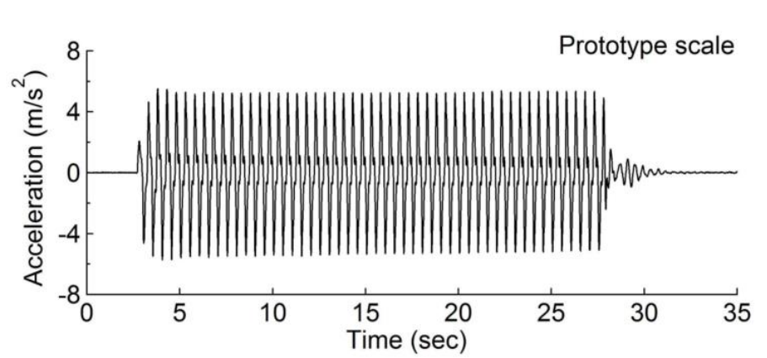

Figure Seismic wave profile of the prototype scale

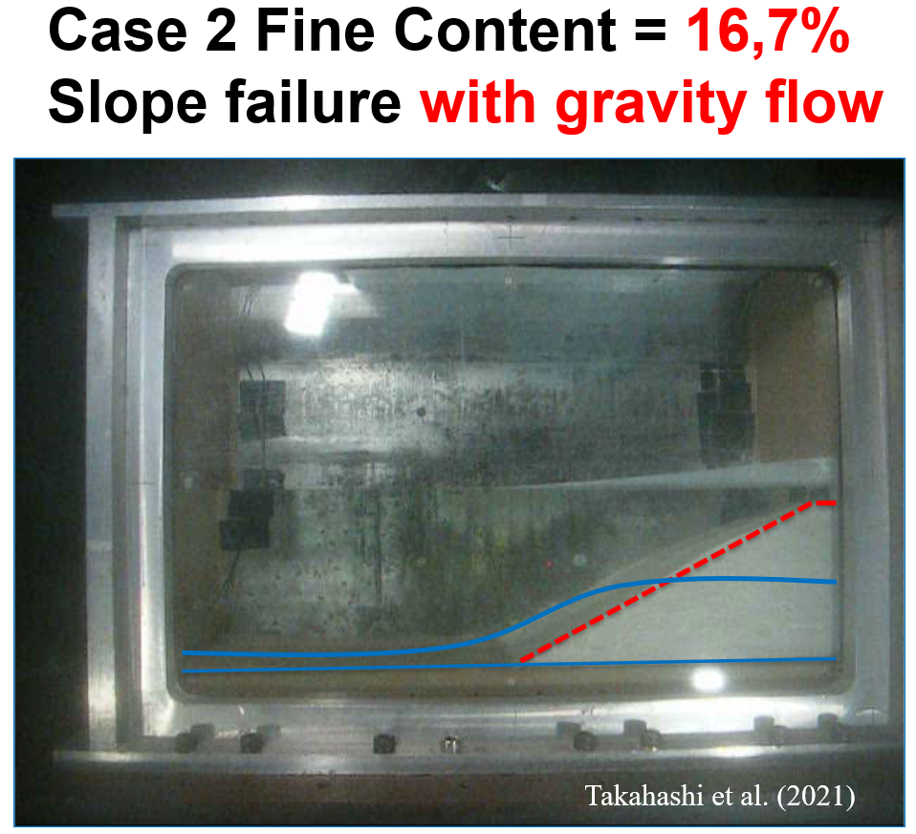

Figure Obervation from the centrifuge experiment, transition from initial slope (red line) to the gravity debris flow (blue line)

## Numerical model and soil parameters



Figure . Numerical simulation with contour of the pore water pressure



Figure . Numerical simulation with contour of the mean effective stress

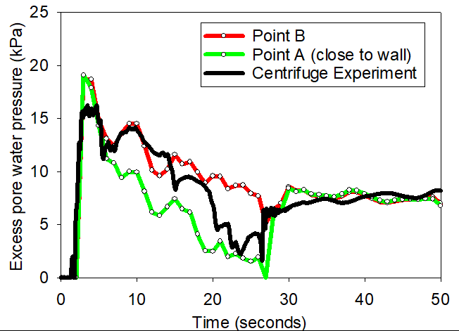

Figure . Comparison between experiment and numerical model in terms of excess pore water pressure

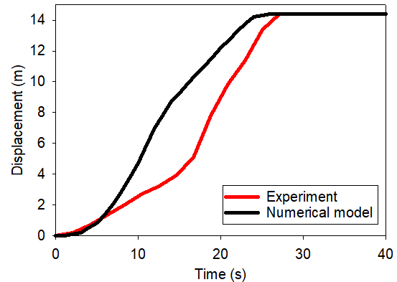

Figure . Comparison between experiment and numerical model in terms of displacement of the toe

# Role of permeability on the failure mechanism

This study considers the base case shown in Figure 1. A 20-meter-high slope with a 45-degree face is placed within a horizontal and vertical structure (plane box). This structure was used as a shaking table to apply earthquake loading. To simplify earthquake loading, we simulated ground shaking for 20 seconds at a peak ground acceleration of 1g and a frequency of 2Hz (Figure 2). Ground motion is expressed in terms of velocity. A magnitude 6 or greater earthquake can produce a similar frequency and peak ground acceleration. To highlight the role of hydraulic conductivity on the failure mechanism of earthquake-induced submarine landslides, two simulations are analysed: (1) A low hydraulic conductivity case, to mimic clay behaviour and (2) a high hydraulic conductivity case to mimic the sand behaviour. The hydraulic conductivity is calculated based on the size of the soil grain, the viscosity of the fluid, and the porosity.

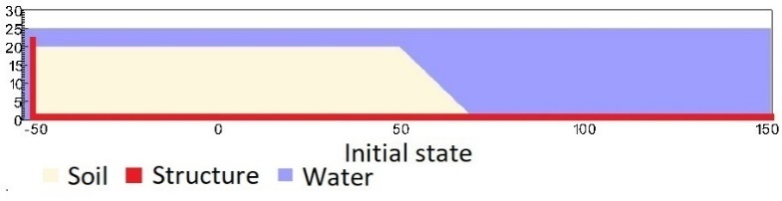

Figure . Geometry of the base case slope

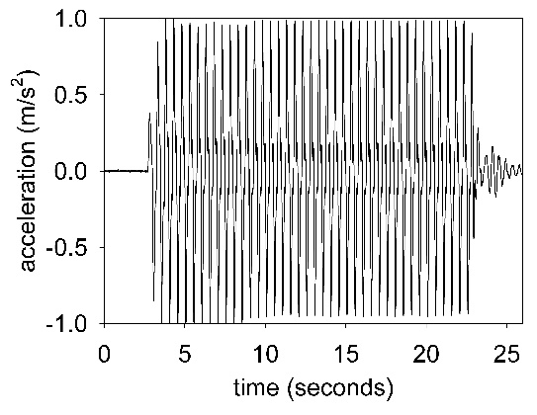

Figure . Ground acceleration profile, frequency of 2Hz and magnitude of 1g

Under gravity, the density of the water at the water surface is 9.998 kN/m3 at the pressure of 1 atm and at the temperature of 10 °C. At the top boundary, the air has a density of 1.17 kg/m3 at the atmospheric pressure of 1 atm. At 10 Celsius degrees, air and water have viscosity of 18.45e-3 mPa s and 1 mPa s respectively. On all boundary faces, the symmetric boundary condition is imposed, while the Neuman boundary condition is imposed at the top boundary for pressure (dp/dx = 0 kPa) and density (d/dx = 0 kg/m3). The mesh size is 0.25 x 025m with 300852 element cells and 142316 material points. We consider constant temperature in the entire domain (isothermal condition) and we do not calculate the thermal expansion and thermal conduction in the numerical simulations.

## Role of permeability on the runout of the slope

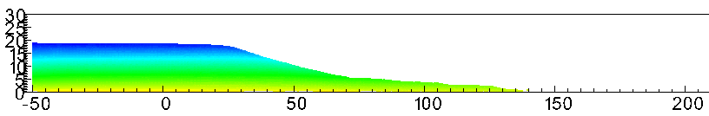

1. **Simulation with soil parameter adopted from centrifuge validation and using high permeability. Color represent pore water pressure**

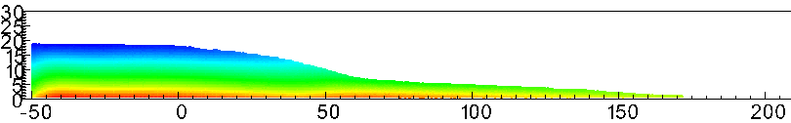

1. **Simulation with soil parameter adopted from centrifuge validation and using low permeability. Color represent pore water pressure**

Figure . Influence of permeability, on top (a) the gravity debris flow stops running and, on the bottom, (b) the gravity debris flow still running due to slow dissipation of the excess pore water pressure in sediment

## Role of permeability on the runout of the slope

We compare simulations with the same input parameters except for the grain size Dp. For both cases, we demonstrate the entire process and the mechanism of earthquake-induced submarine landslides and discuss to the differences in the mechanisms.

The initial stress condition is generated by running the simulations for 10 seconds with every high hydraulic conductivity ($D_{p}$ = 1m). The slope is fully consolidated after 10s under the gravity to create the initial effective stress and initial pore water pressure (see Figure 6a).

## *Soil Models*

A non-associated Mohr-Coulomb model is used for the soil. Because the Young's modulus has negligible effect on the simulations (in which plastic deformation is dominant) based on sensitivity analysis, the Young's modulus is set to be 10 kPa and Poisson's ratio is 0.3 with zero cohesion. The mobilized friction angle ${}_{m}^{ '}$ is governed following the softening curve (Figure 4) with the peak friction angle ${}_{p}^{ '}$ of 45 degrees and the residual friction angle ${}_{r}^{ '}$ of 10 degrees. The mobilized dilatancy angle is calculated from the Rowe-stress dilatancy as follow:

|  |  |  |
| --- | --- | --- |
|  |  | () |

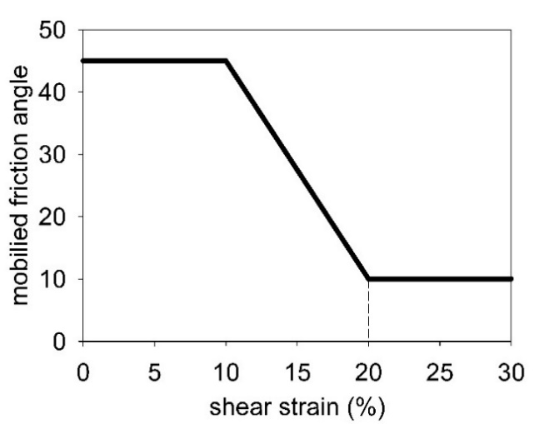

Figure . Mobilized friction angle in Mohr Coulomb

The contact between horizontal plane and the soil is the frictional contact with a friction coefficient of 0.1. No artificial damping is applied in the simulation. The contact between vertical plane and the sand is considered as smooth.

1. *Sand flow slide (high permeability soil)*

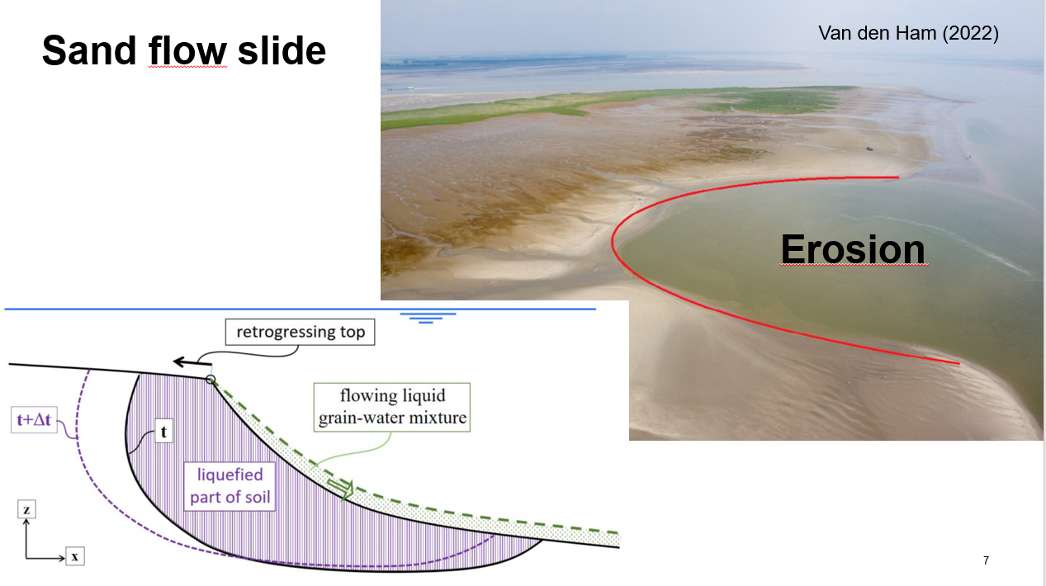

Figure . Sand flow slide mechanism

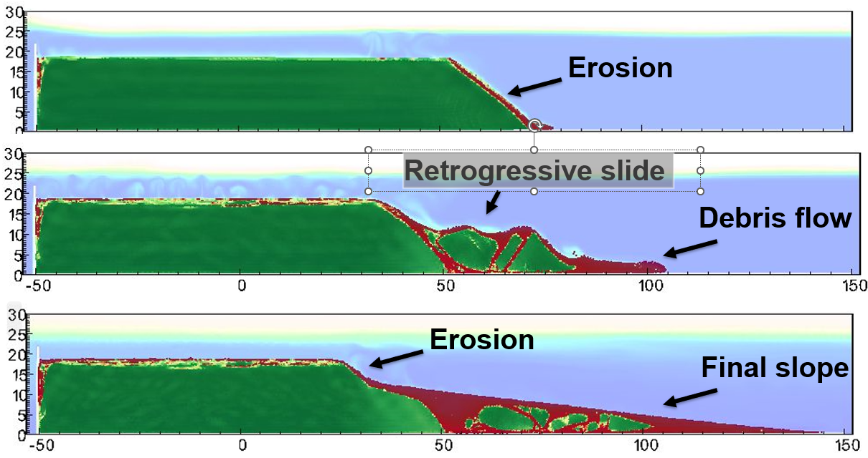

Figure . Simulation of sand flow slide

**

Figure . Pore water pressure



Figure . Mean effective stress

1. *Clay spreading (low permeability soil)*

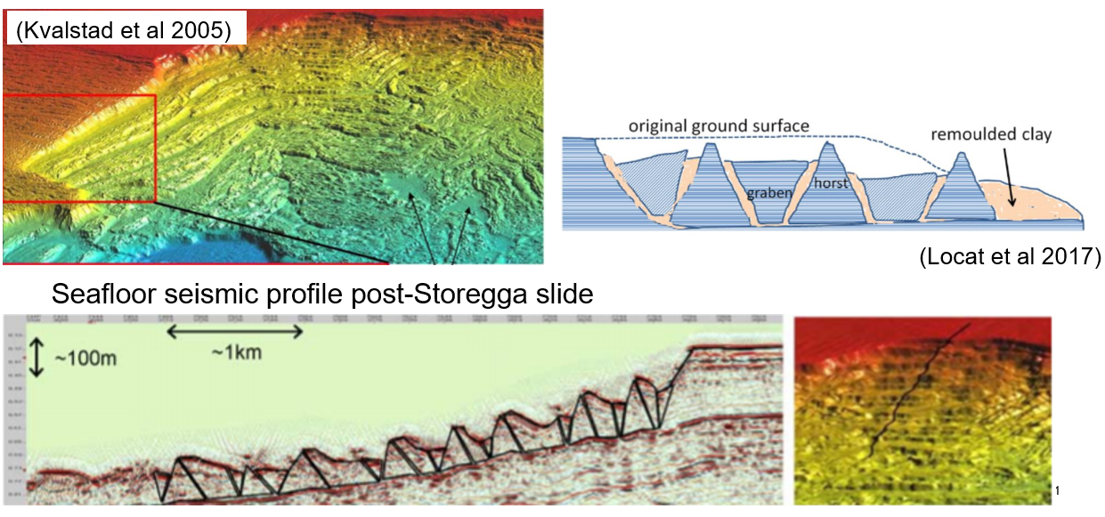

Figure . Clay spreading mechanism



Figure . Shear strain

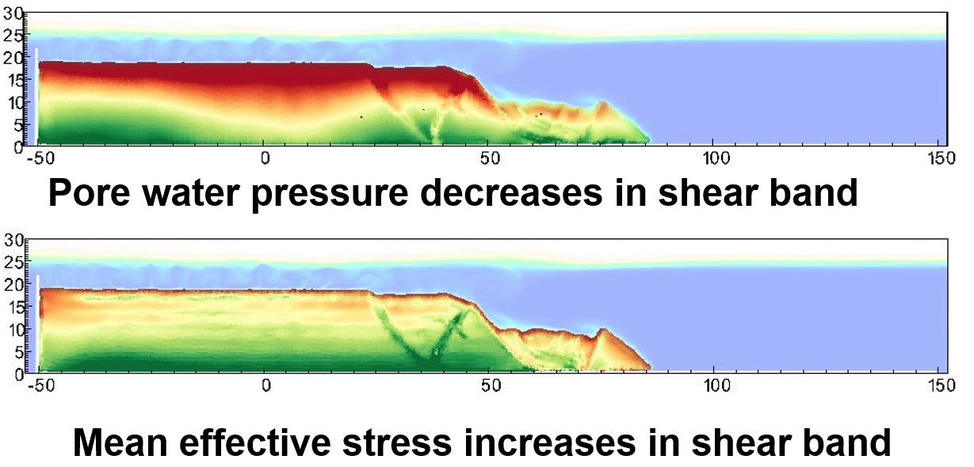

Figure . Soil dilation in the shear band

# Conclusion

# Acknowledgements

The research received support from the European Union’s Horizon 2020 research and innovation program under the grant agreement 101022007. The computations were performed on High Performance Computing resources provided by UNINETT Sigma2 - the National Infrastructure for High Performance Computing and Data Storage in Norway. We would like to express our gratitude to the Soil Dynamics Group of the Port and Airport Research Institute in Yokosuka, Japan for their generous hospitality during our research visits in Japan.

# Code availability

Instructions for replicating the numerical results in this paper are given at the open-source platform GitHub. Also, the open-source code is shared in this platform for interested users to take up and make use of the results.

# Reference

Bandara, S., & Soga, K. (2015). Coupling of soil deformation and pore fluid flow using material point method (vol 663, pg 199, 2015). *Computers and Geotechnics*, *65*, 302-302. <https://doi.org/10.1016/j.compgeo.2014.12.007>

Capone, T., Panizzo, A., & Monaghan, J. (2010). SPH modelling of water waves generated by submarine landslides. *Journal ofHydraulic Research*, *48*(1), 80-84.

Dey, R., Hawlader, C., Phillips, R., & Soga, K. (2016). Numerical modelling of submarine landslides with sensitive clay layers. *Géotechnique*, *66*(6), 454-468.

Harbitz, C. B., Lovholt, F., & Bungum, H. (2014). Submarine landslide tsunamis: how extreme and how likely? *Natural Hazards*, *72*(3), 1341-1374. <https://doi.org/10.1007/s11069-013-0681-3>

Heezen, B. C., & Ewing, M. (1952). Turbidity Currents and Submarine Slumps, and the 1929 Grand-Banks Earthquake. *American Journal of Science*, *250*(12), 849-873. <https://doi.org/DOI> 10.2475/ajs.250.12.849

Locat, J., & Lee, H. J. (2002). Submarine landslides: advances and challenges. *Canadian Geotechnical Journal*, *39*(1), 193-212. <https://doi.org/10.1139/T01-089>

Parsons, T., Geist, E. L., Ryan, H. F., Lee, H. J., Haeussler, P. J., Lynett, P., Hart, P. E., Sliter, R., & Roland, E. (2014). Source and progression of a submarine landslide and tsunami: The 1964 Great Alaska earthquake at Valdez. *Journal of Geophysical Research-Solid Earth*, *119*(11), 8502-8516. <https://doi.org/10.1002/2014jb011514>

Puzrin, A. M. (2016). Simple criteria for ploughing and runout in post-failure evolution of submarine landslides. *Canadian Geotechnical Journal*, *53*(8), 1305-1314. <https://doi.org/10.1139/cgj-2015-0582>

Shi, J. J., Zhang, W., Wang, B., Li, C. Y., & Pan, B. (2020). Simulation of a Submarine Landslide Using the Coupled Material Point Method. *Mathematical Problems in Engineering*, *2020*. <https://doi.org/Artn> 439258110.1155/2020/4392581

Takahashi, H., Fujii, N., & Sassa, S. (2020). Centrifuge model tests of earthquake-induced submarine landslide. *International Journal of Physical Modelling in Geotechnics*, *20*(4), 254-266. <https://doi.org/10.1680/jphmg.18.00048>

Tran, Q. A., Berzins, M., & Sołowski, W. (2019). An improved moving least squares method for the Material Point Method. International Conference on the Material Point Method for Modelling Soil-Water-Structure Interaction, Cambridge, UK.

Tran, Q. A., Grimstad, G., & Ghoreishian Amiri, S. A. (2022). MPMICE: A hybrid MPM-CFD model for simulating coupled problems in porous media. Application to earthquake-induced submarine landslides. *arXiv preprint*.

Tran, Q. A., & Sołowski, W. (2019). Temporal and null-space filter for the material point method. *International Journal for Numerical Methods in Engineering*, *120*(3), 328-360.

Tran, Q. A., Wobbes, E. D., Sołowski, W., Moller, M., & Vuik, C. (2019). Moving least squares reconstruction for B-spline Material Point Method. International Conference on the Material Point Method for Modelling Soil-Water-Structure Interaction, Cambridge, UK.

Zhang, X., Onate, E., Torres, S. A. G., Bleyer, J., & Krabbenhoft, K. (2019). A unified Lagrangian formulation for solid and fluid dynamics and its possibility for modelling submarine landslides and their consequences. *Computer methods in applied mechanics and engineering*, *343*, 314-338.

Zheng, X., Pisano, F., Vardon, P., & Hicks, M. A. (2021). An explicit stabilised material point method for coupled hydromechanical problems in two-phase porous media. *Computers and Geotechnics*, *135*, 104112.